## horizontal line

Regularization

26.01.2025

[Regularization](https://colab.research.google.com/drive/1alyKAH4mCHxLogQv5RQtoZ5pOOlMW7PY)

# Why does Overfitting occur ?

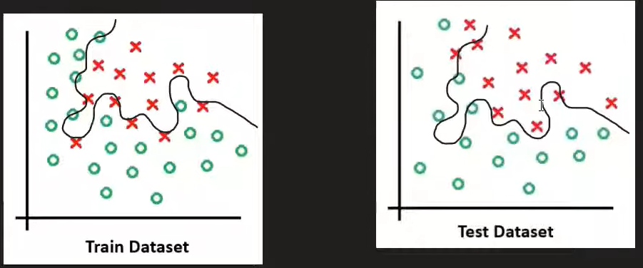

When there is a perceptron , only one node is there that captures a single feature and it causes linear classification . When nodes increase more features are being captured that start creating curves and complex patterns of classification . Rather than learning the concept / basis of classification it starts learning the minute patterns to not miss any point misclassified . so when a new test data is provided it performs poorly .

# Ways to solve overfitting



# Regularization

Add a penalty to parameters so that their weight is close to zero and the node resembles non-existence . Thus it captures less features and does not form such complex patterns .

C = L(yi , yi_hat) + P

C = L +

This is L2 . By adding this penalty weights started closing to zero .Only weights are added, not bias . L1 remains the same the square of Wi.

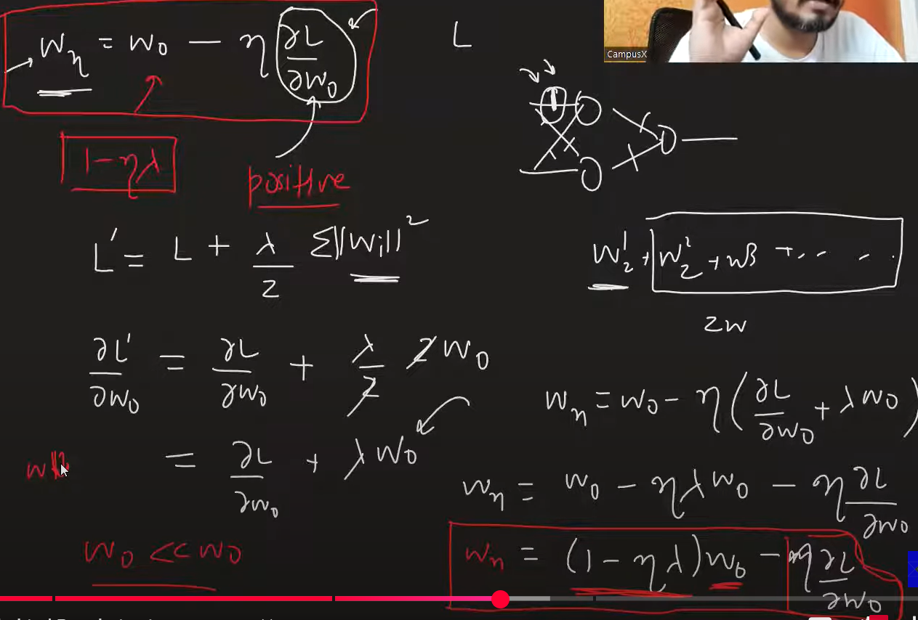

This is weight decay . “w” becomes very small but not zero.